Test Exercise 2 – GPA

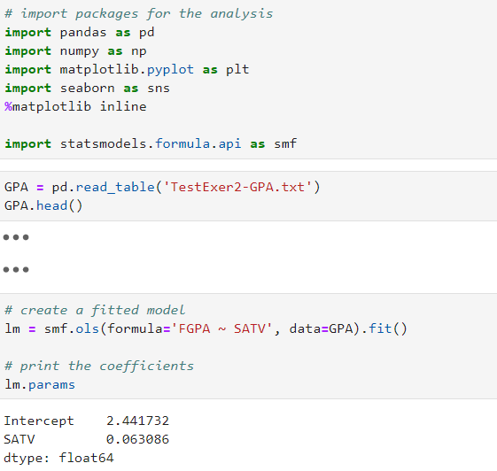



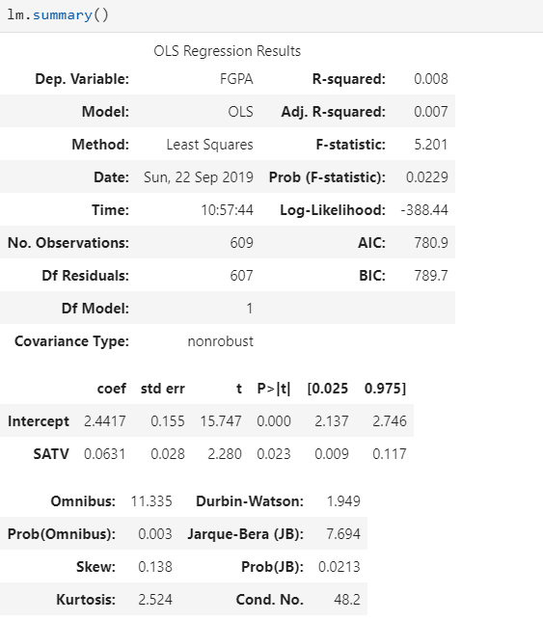

1. So for the model *FGPA* = a+b\**SATV* ,

b = 0.063, standard error of b is 0.028, P-value is 0.023

1. 95% CI of SATV’s increasing by 1 on FGPA is [0.009, 0.117]

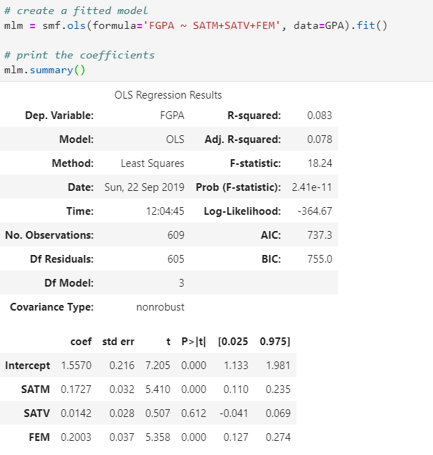

1. So for the model *FGPA* = a+b1\**SATM*+b2\**SATV*+b3\**FEM* ,

b2 = 0.014, standard error of b2 is 0.028, P-value is 0.612

1. 95% CI of SATV’s increasing by 1 on FGPA is [-0.041, 0.069]
2. The correlation Matrix:

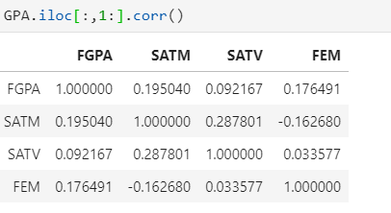

It shows that the correlation between SATV and FGPA is less than 10% and much smaller than the other two pairs. So when stronger predictors introduced into the model, the influence of SATV will become insignificant.



H0: b2 = 0

H1: b2 ≠ 0

Analyze the restricted model:

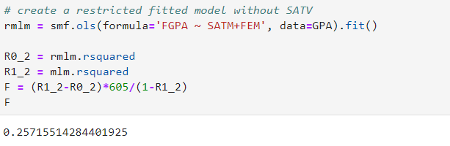

We get F = 0.257155 < 3.9. So, the effect of SATV on FGPA is insignificant.

As we know from (b) that t^2 of b2 is 0.507105^2 = 0.257155

Clearly, F = t^2